Git Hands-on Lab 3 Report - Branching and Merging

Objective
Create a new Git branch, make changes in the branch, merge it with the master branch, view the commit history, and delete the merged branch.

Prerequisites
- Git installed and configured
- Existing GitDemo repository
- Notepad++ configured as default editor
- P4Merge (optional, if required by faculty)

Procedure
Step 1: Open repository
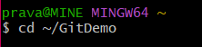
Step 2: Create a branch
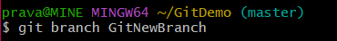
Step 3: List branches
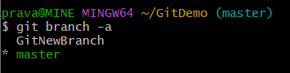
Step 4: Switch to new branch
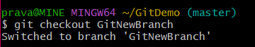
Step 5: Create a file
Step 6: View file
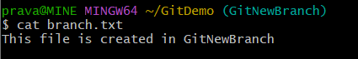
Step 7: Check status
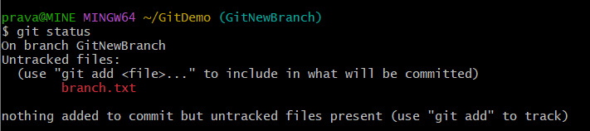
Step 8: Stage file
Step 9: Commit changes
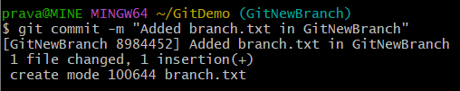
Step 10: Verify status
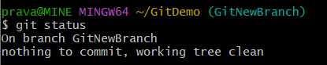
Step 11: Switch to master
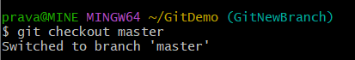
Step 12: Compare branches
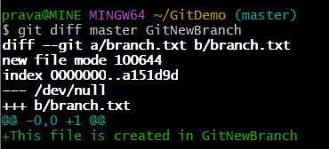
Step 13: Merge branch
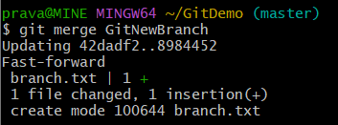
Step 14: View commit history
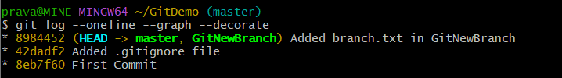
Step 15: Delete merged branch
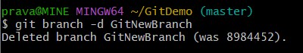
Step 16: Final verification
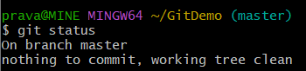

Result
The branch 'GitNewBranch' is created successfully, changes are committed in the branch, merged into the master branch, the commit history displays the merge, and the repository ends with 'nothing to commit, working tree clean'.


Conclusion
Branching and merging were performed successfully. Changes created in GitNewBranch were merged into the master branch, the commit history was verified, and the merged branch was deleted.

